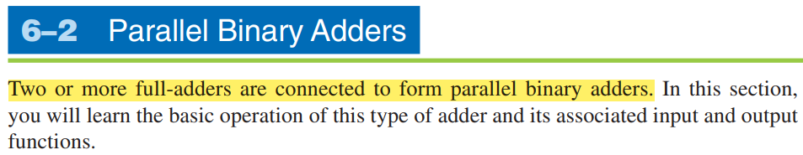

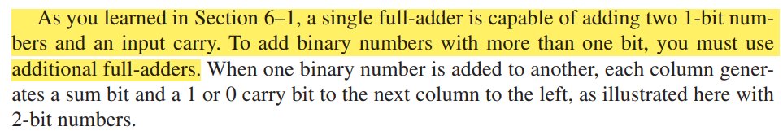

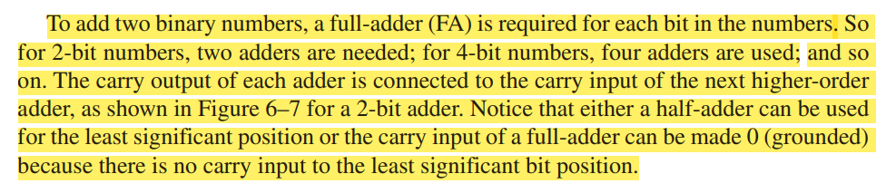

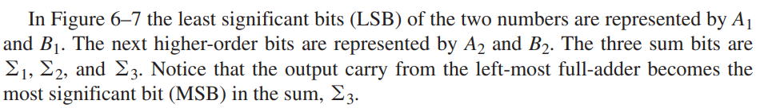

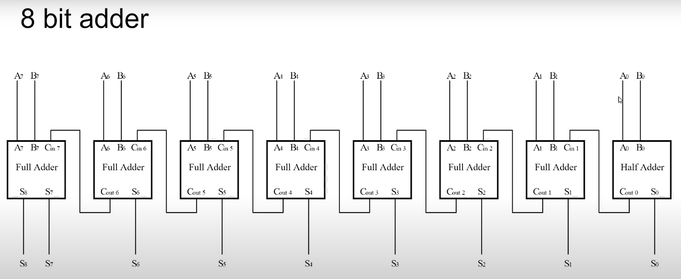

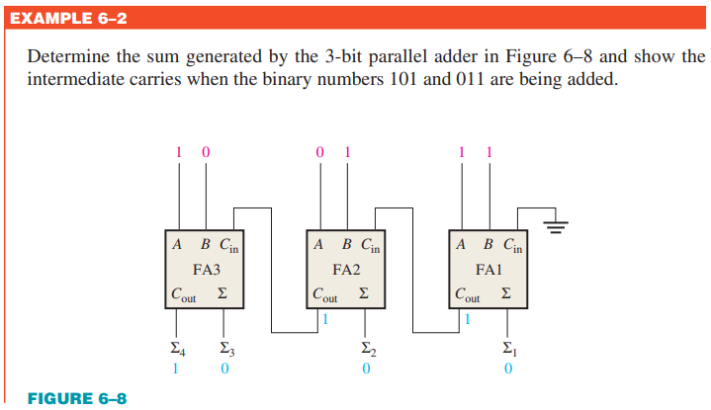

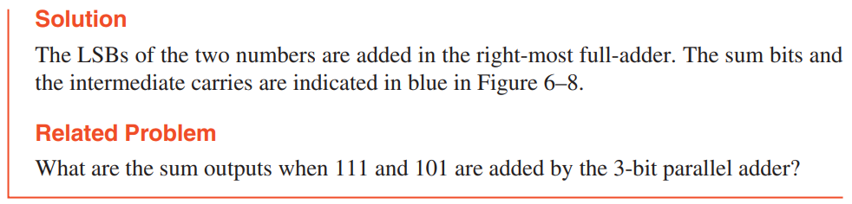

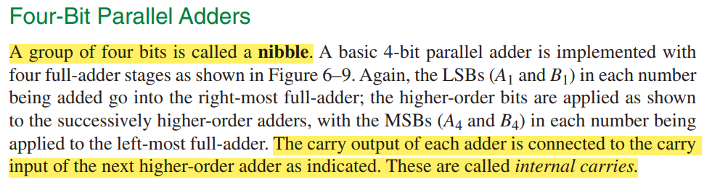

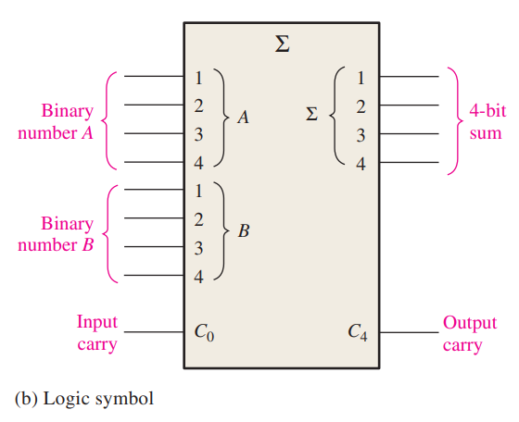

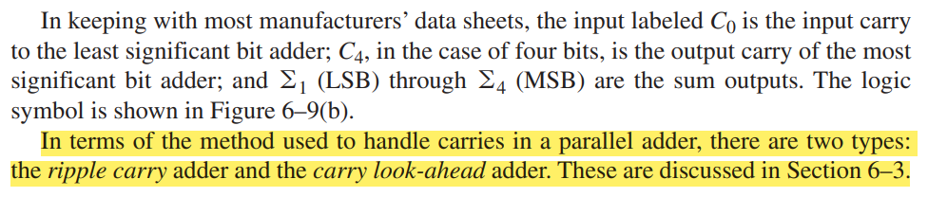

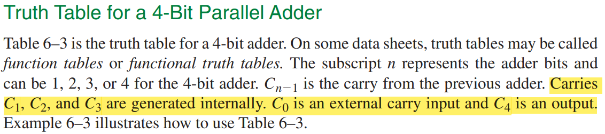

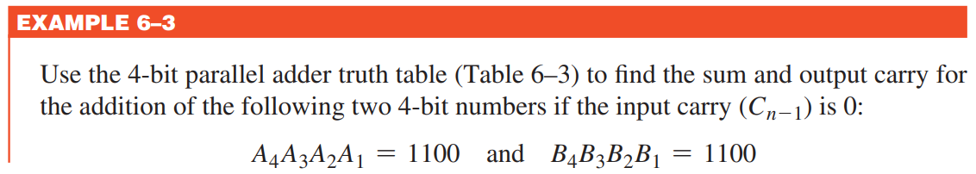

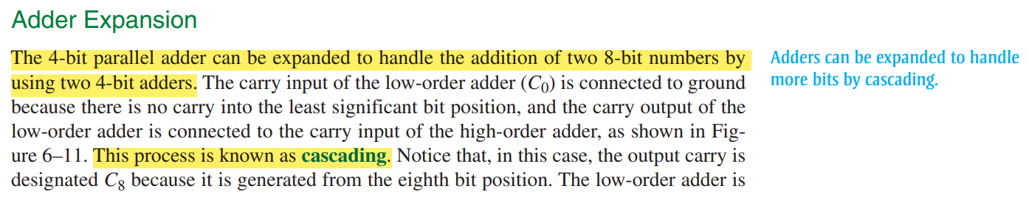

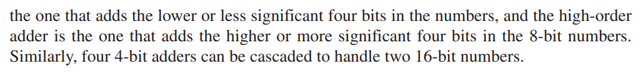

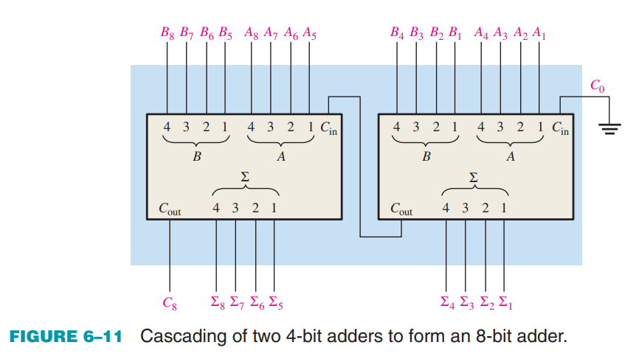

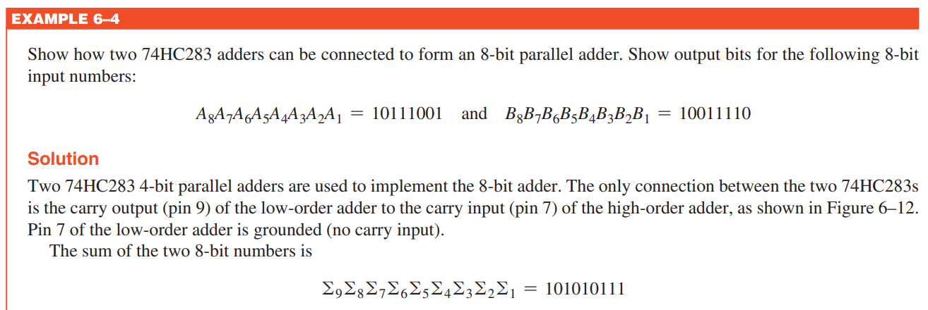

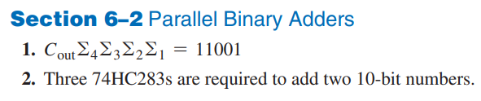

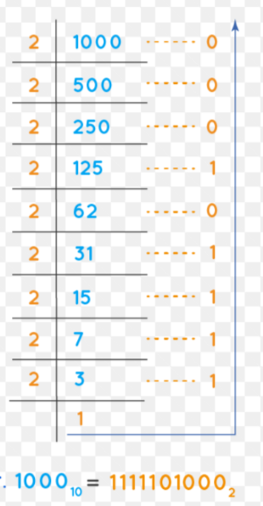

(1000)10 = (1111101000) = 10-bits